**4.2 Standard Form of a Quadratic Function**

**Standard Form:** a function of the form

$f\left(x\right)=ax^{2}+bx+c$ where $a≠0$

**Parabola:** the “U shaped” graph that is formed by a quadratic function

**Vertex Form:** another way of writing a quadratic equation,

$f\left(x\right)=a{(x-h)}^{2}+k$ where $a≠0$

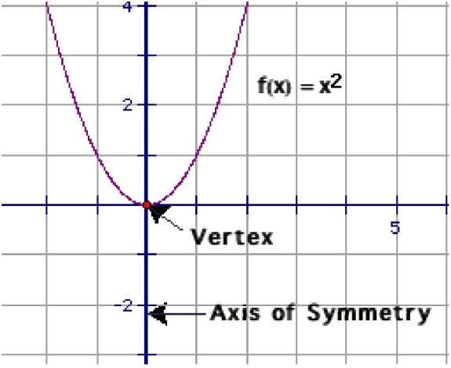Note: it is called vertex form because are able to easily identify the vertex

**Vertex:** the highest (maximum) or lowest (minimum) point of a parabola where the axis of symmetry intersects our parabola (h, k)

**Axis of Symmetry:** The vertical line that divides are parabola into two mirror images of each other by passing through the vertex.

**Parent Graph $f\left(x\right)=x^{2}$**

**Standard Form;**

|  |  |  |
| --- | --- | --- |
| **Form** | **Equation** | **Characteristics** |
| *Standard* | y = ax2 + bx + c | x-coordinate of vertex is |
| axis of symmetry is |

*Examples:*

*Write the equation in Standard Form:*

1. y = (x + 1)(x + 2)

$y=x^{2}+3x+2$

1. y = - 2(x + 4)(x – 3)

1. y = 4(x + 1)2 + 5

[Steps to Graphing Quadratic Equation in Standard Form:](//Standard_Form.ggb)

**Identify a, b and c.**

**1) Find and Plot Vertex**

* , Substitute in x and solve for y

**2) Draw Axis of Symmetry**

* Vertical line at 

**3) Find and Plot two points on one side of axis of symmetry**

* Choose x values and solve for y values

**4) Use symmetry to plot symmetric points on opposite side of axis of symmetry**

**5) Draw a parabola through the plotted points**

*Graph the equation:*

y = x2 + 2x – 1

y = 2x2 – 8x + 6



**HMWK: pg 206 #1-3, 7, 9-11, 32, 38, 43**